SAKSHI ROY

1BM19CS140

OOJ LAB RECORD-2

LAB 6:

Create a package CIE which has two classes, Student and Internals. Student class has members such as, name, USN and semester. Intenals class has an array that stores internal marks of all the 5 subjects in the current semester. Create another package SEE which has a class External derived from Student and has an array storing external marks. Import both packages in a file calculating the final marks of students.

TYPED PROGRAM:

package CIE;

import java.util.Scanner;

public class Student

{

public String name;

public String usn;

public int sem;

public void display()

{

Scanner s=new Scanner(System.in);

System.out.println("Name:");

name=s.next();

System.out.println("USN:");

usn=s.next();

System.out.println("Semester:");

sem=s.nextInt();

}

}

package CIE;

import java.util.Scanner;

public class Internals extends Student

{

public double ciem[];

public void display()

{

ciem=new double[5];

Scanner t=new Scanner(System.in);

System.out.println("CIE Marks for 5 subjects(out of 50):");

for(int i=0;i<5;i++)

ciem[i]=t.nextDouble();

}

}

package SEE;

import java.util.\*;

import CIE.\*;

public class Externals extends CIE.Student

{

public double seem[];

public void display()

{

seem=new double[5];

Scanner s=new Scanner(System.in);

System.out.println("SEE Marks for 5 subjects(out of 100):");

for(int i=0;i<5;i++)

seem[i]=s.nextDouble();

}

}

import CIE.\*;

import SEE.\*;

import java.util.Scanner;

public class Main

{

public static void main(String args[])

{

int n;

Scanner s=new Scanner(System.in);

System.out.println("Enter the number of students:");

n=s.nextInt();

CIE.Student st[]=new CIE.Student[n];

CIE.Internals in[]=new CIE.Internals[n];

SEE.Externals e[]=new SEE.Externals[n];

for(int i=0;i<n;i++)

{

st[i]=new CIE.Student();

in[i]=new CIE.Internals();

e[i]=new SEE.Externals();

st[i].display();

in[i].display();

e[i].display();

System.out.println("Total marks of student"+st[i].name+" in 5 subjects are:");

for(int j=0;j<5;j++)

{

System.out.println(in[i].ciem[j]+(e[i].seem[j]/2));

}

}

}

}

WRITE-UP:

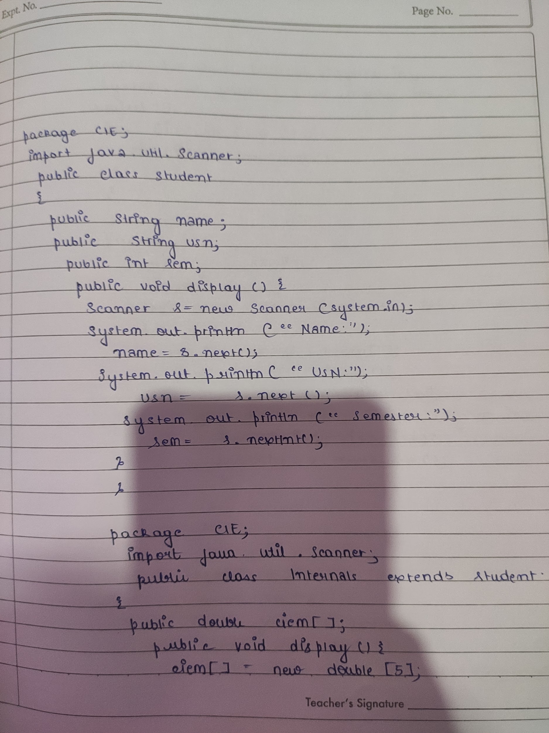

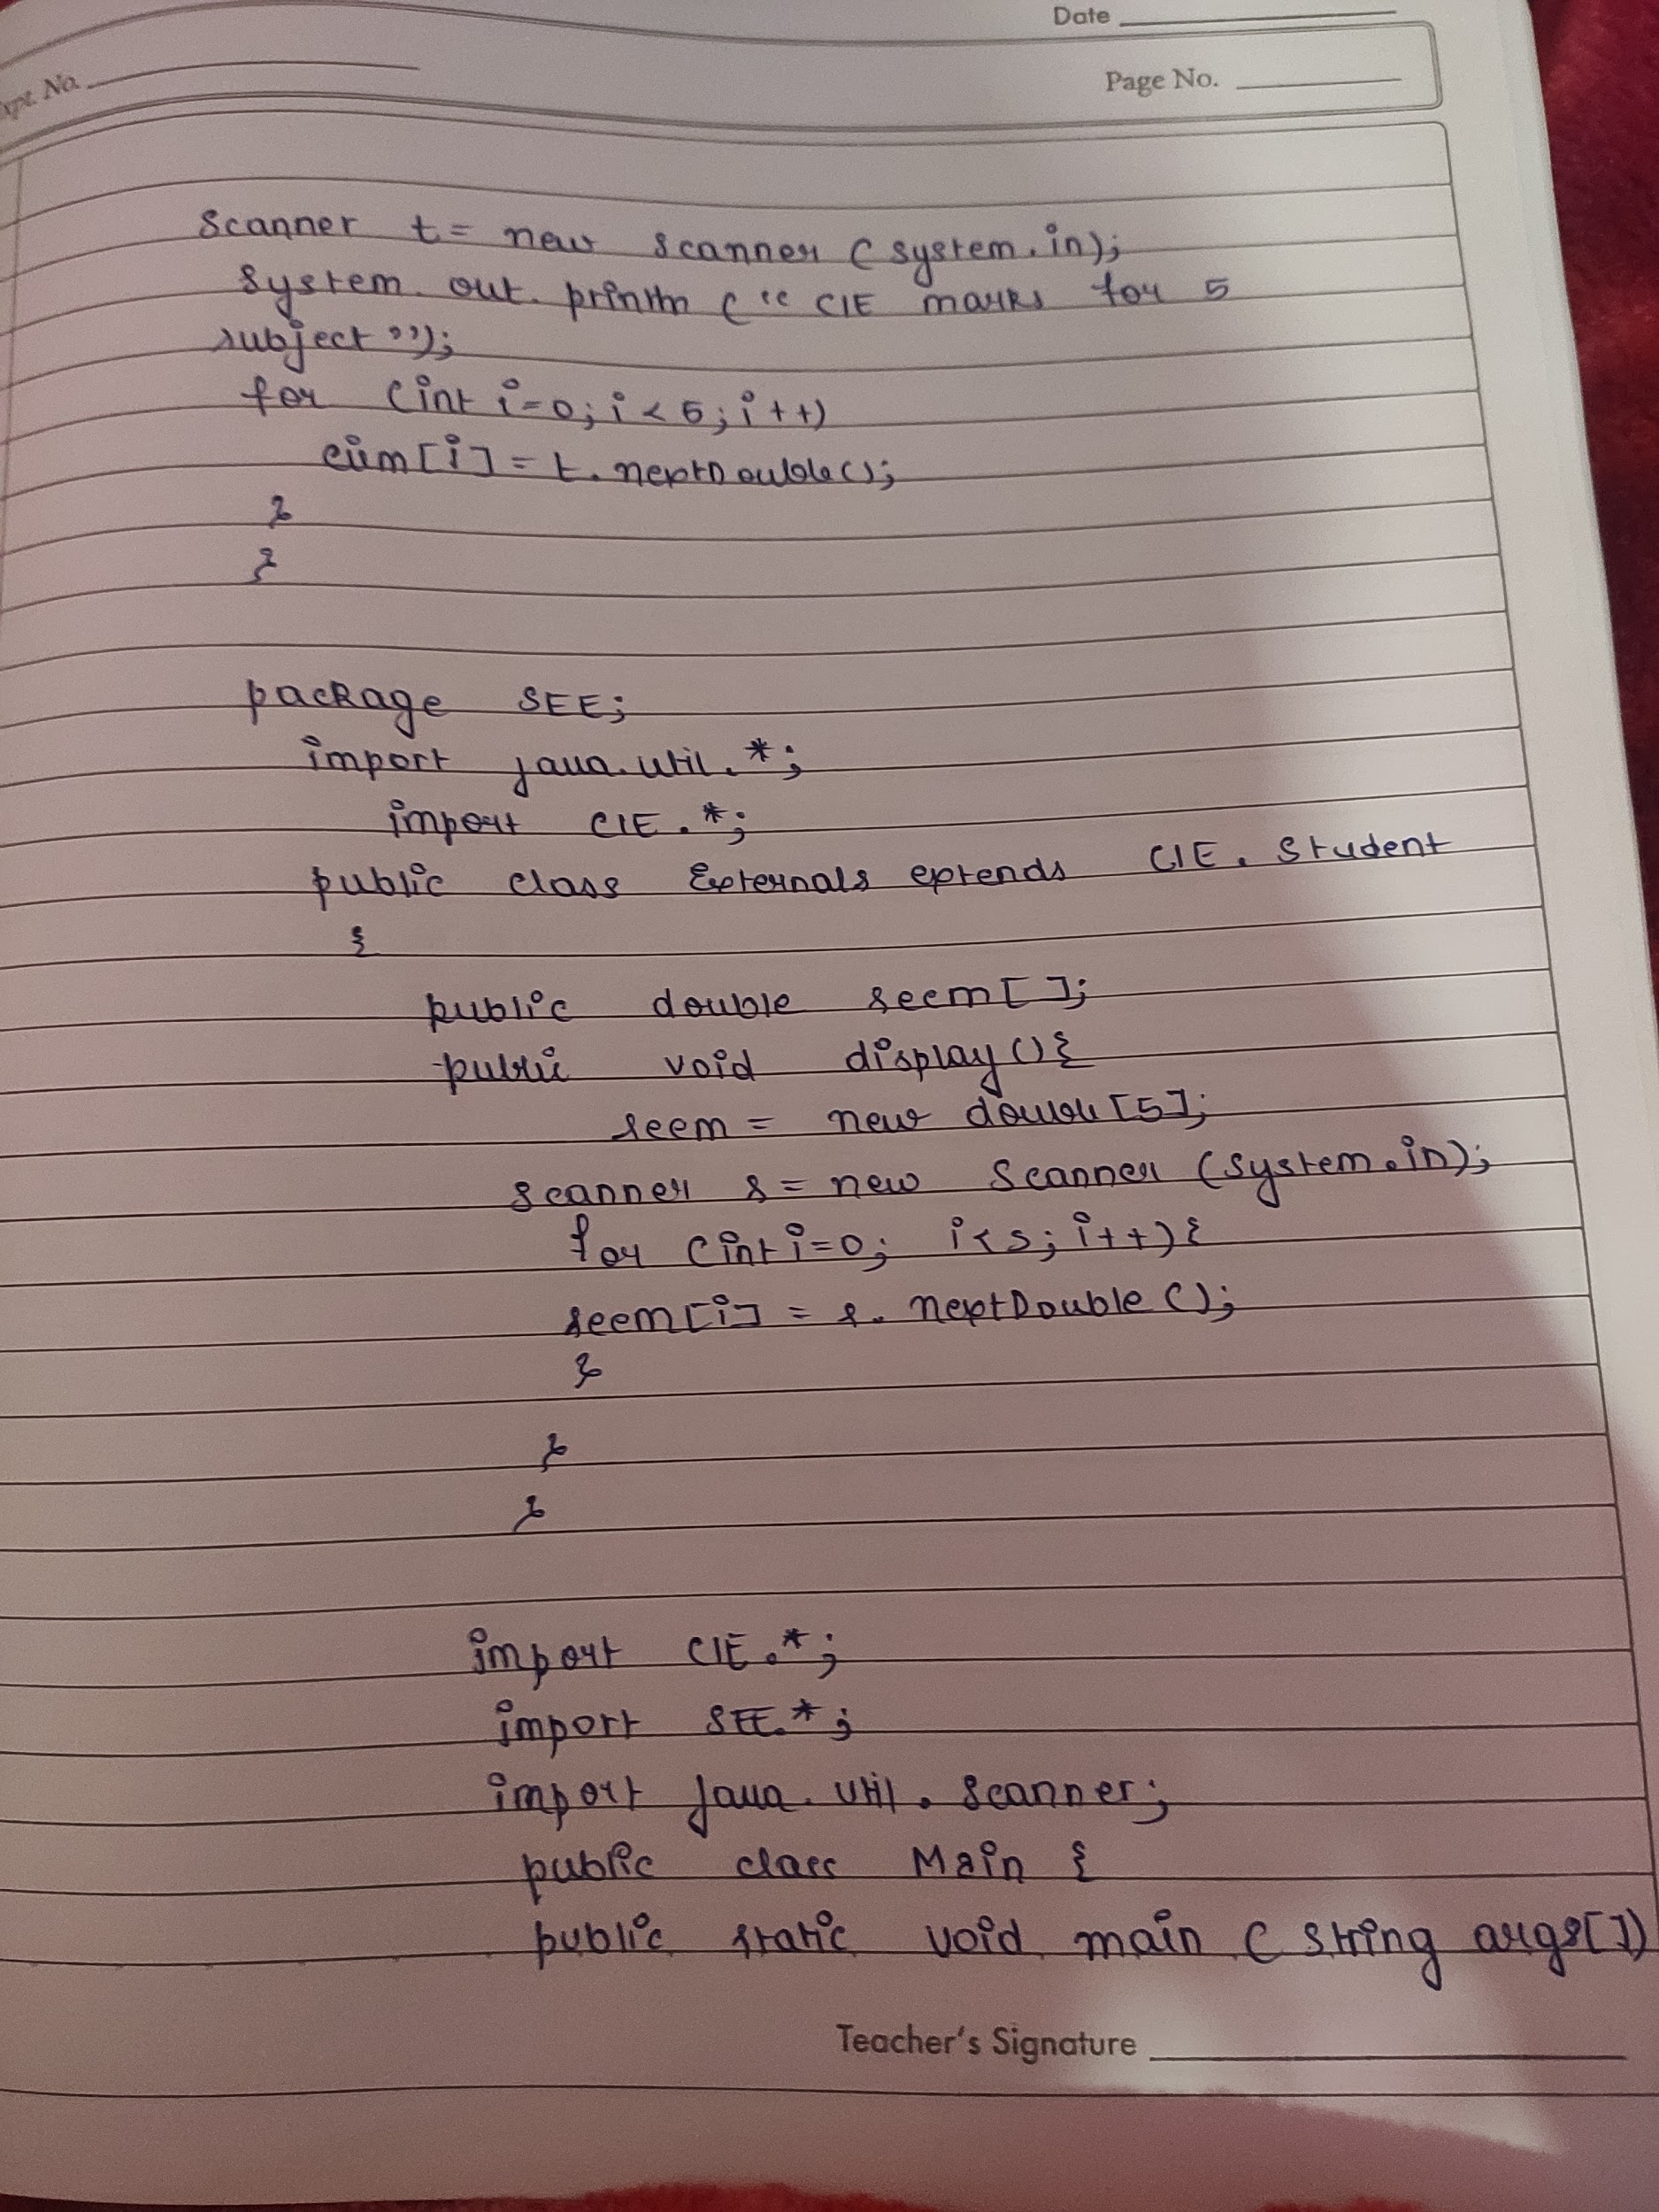

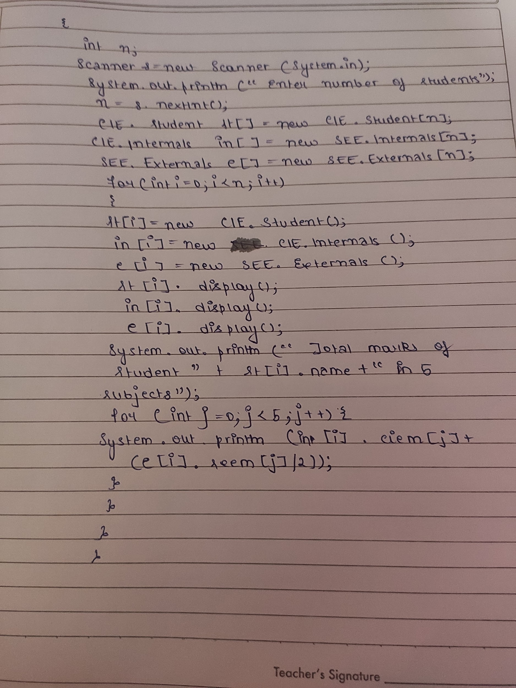

OUTPUT:

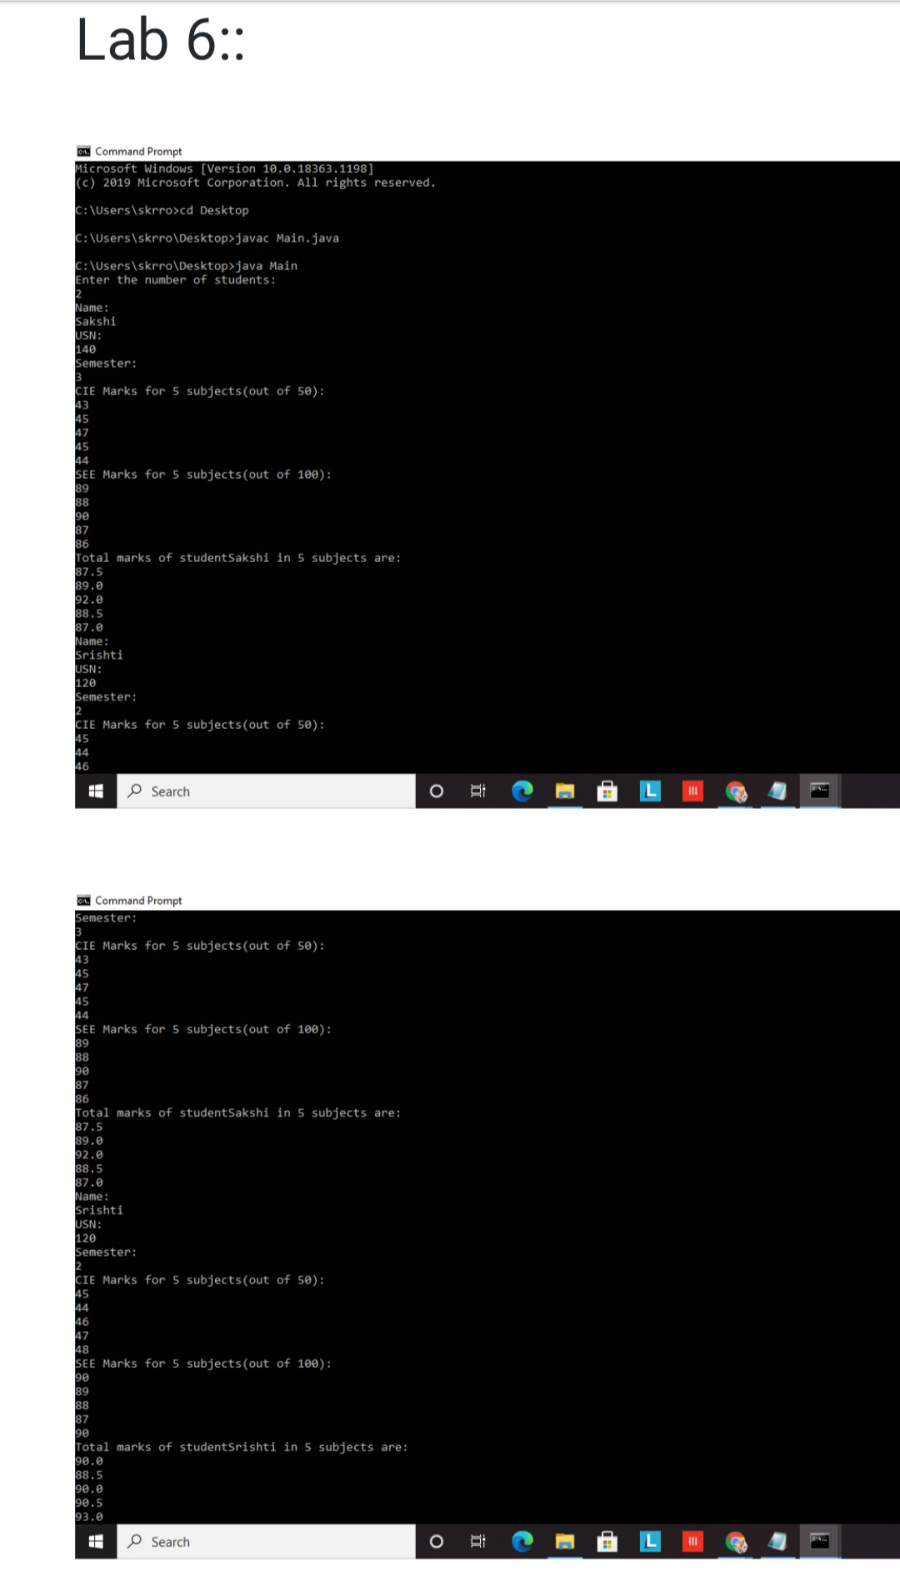

LAB 7:

Demonstrating generics using multiple object parameters.

TYPED PROGRAM:

class myGen<a,b>{

a obj1;

b obj2;

myGen(a obj1, b obj2){

this.obj1 = obj1;

this.obj2 = obj2;

}

void Display(){

System.out.println(obj1);

System.out.println(obj2);

}

}

public class Genericsmain{

public static void main(String args[]){

myGen<Integer,Double>myG1 = new myGen<Integer,Double>(24,34.4);

myGen<Character,Double>myG2 = new myGen<Character,Double>('A',101.2);

myG1.Display();

myG2.Display();

}

}

WRITE-UP

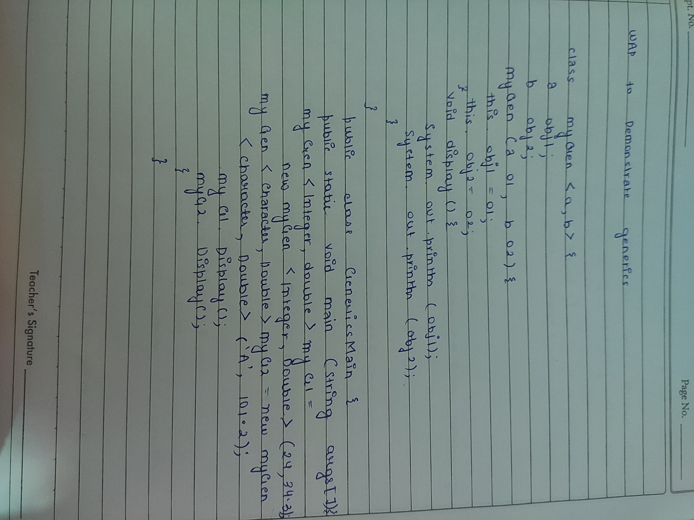

OUTPUT:

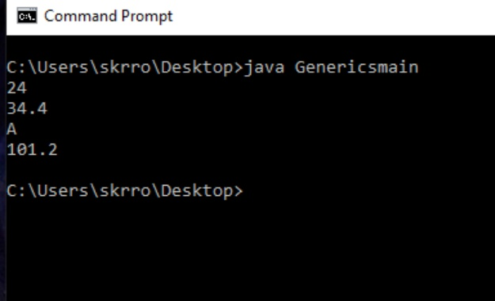

LAB 8:

Create a base class father and a derived class Son. Father class has a constructor that takes father's age and throws an exception when age≤0. Son class has a constructor that takes both father and son's age. It throws an error when son's age›father's age.

TYPED PROGRAM:

import java.util.Scanner;

class WrongAge extends Exception {

public WrongAge(String s){

super(s);

}

}

class Father {

int fatherAge;

Father(int fAge) throws WrongAge{

if(fAge<0){

throw new WrongAge("Invalid age");

}

else{

this.fatherAge = fAge;

}

}

}

class Son extends Father {

int sonAge;

Son(int fAge, int sAge) throws WrongAge{

super(fAge);

this.sonAge=sAge;

if(sAge >= fAge){

throw new WrongAge("Sons's age is equal to or greater than father's age");

}

}

void Display(){

System.out.println("Father's age: "+fatherAge);

System.out.println("Son's age: "+sonAge);

}

}

public class exp {

public static void main(String[] args){

int fAge,sAge;

Scanner sc = new Scanner(System.in);

System.out.println("Enter father's age: ");

fAge = sc.nextInt();

System.out.println("Enter sons's age: ");

sAge = sc.nextInt();

try{

Son son = new Son(fAge, sAge);

son.Display();

}catch(WrongAge err){

System.out.println("Exception " + err);

}

}

}

WRITE-UP

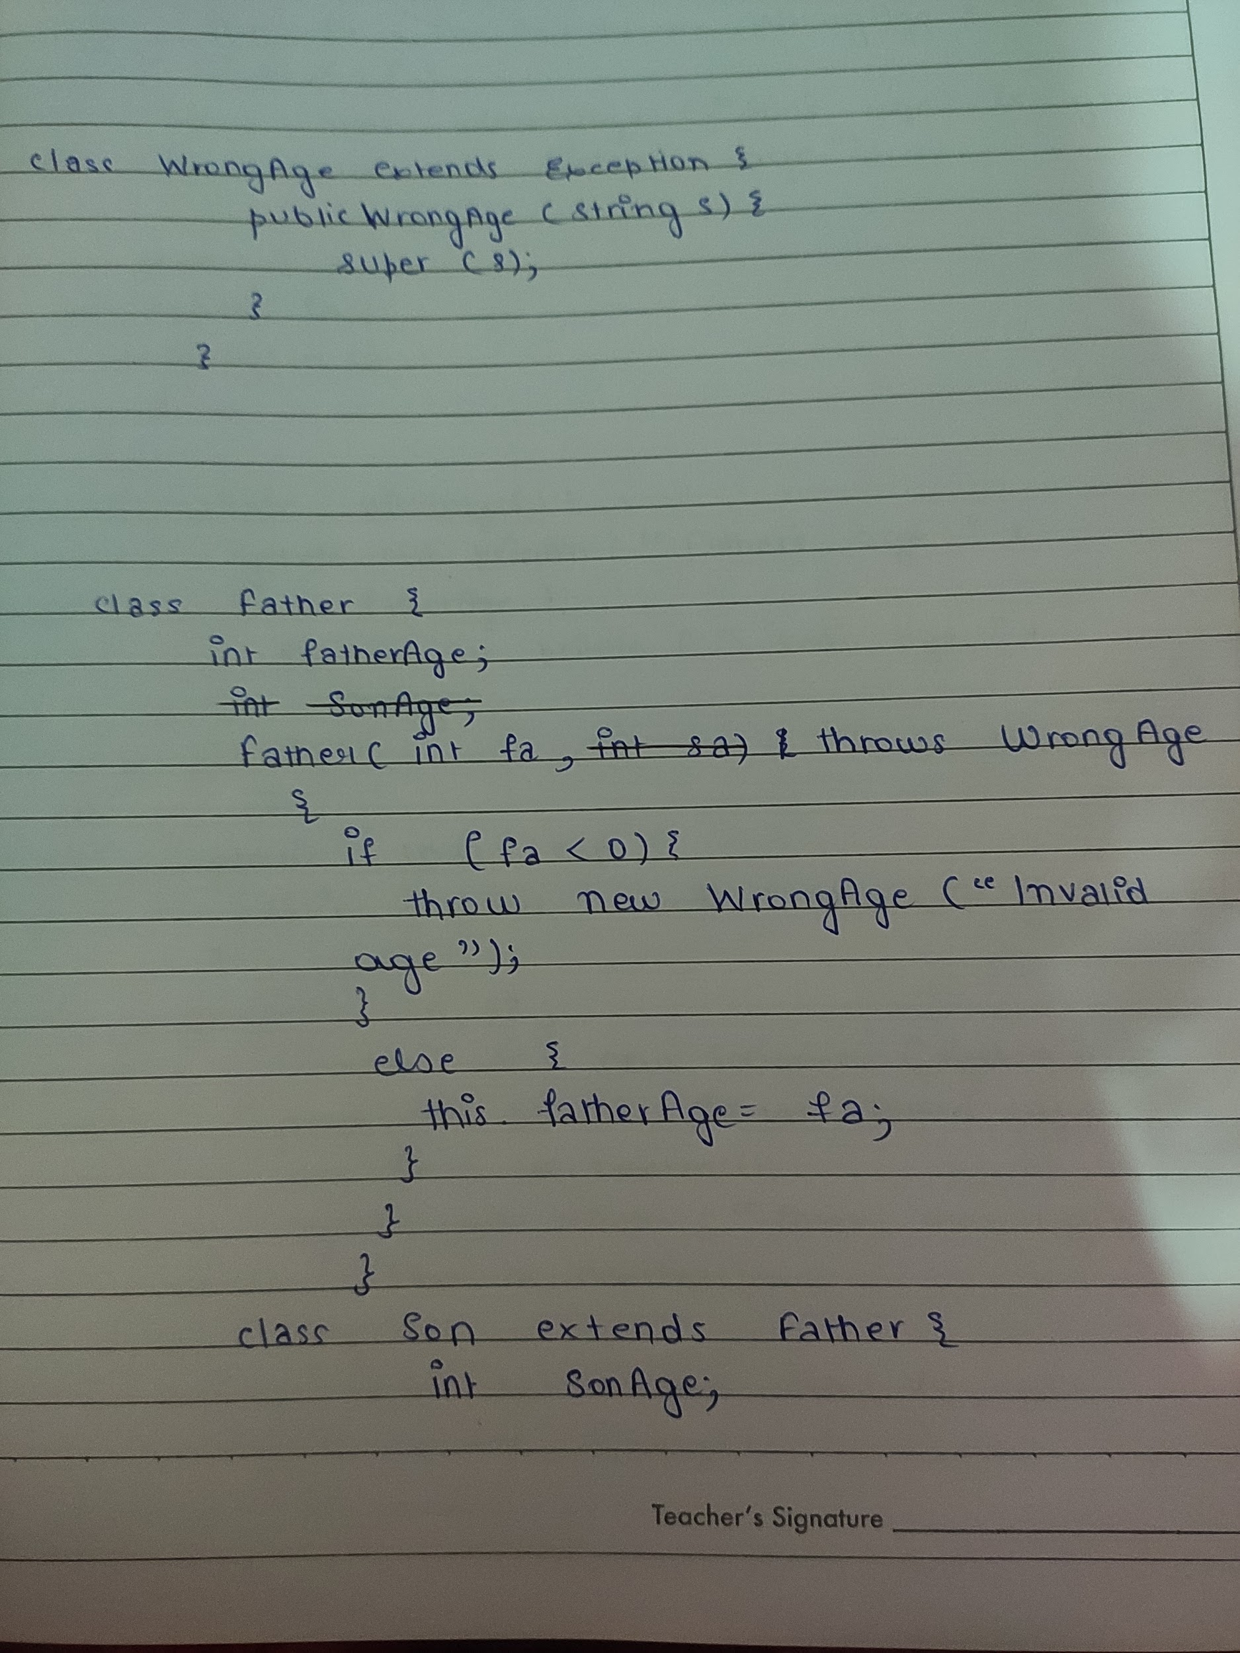

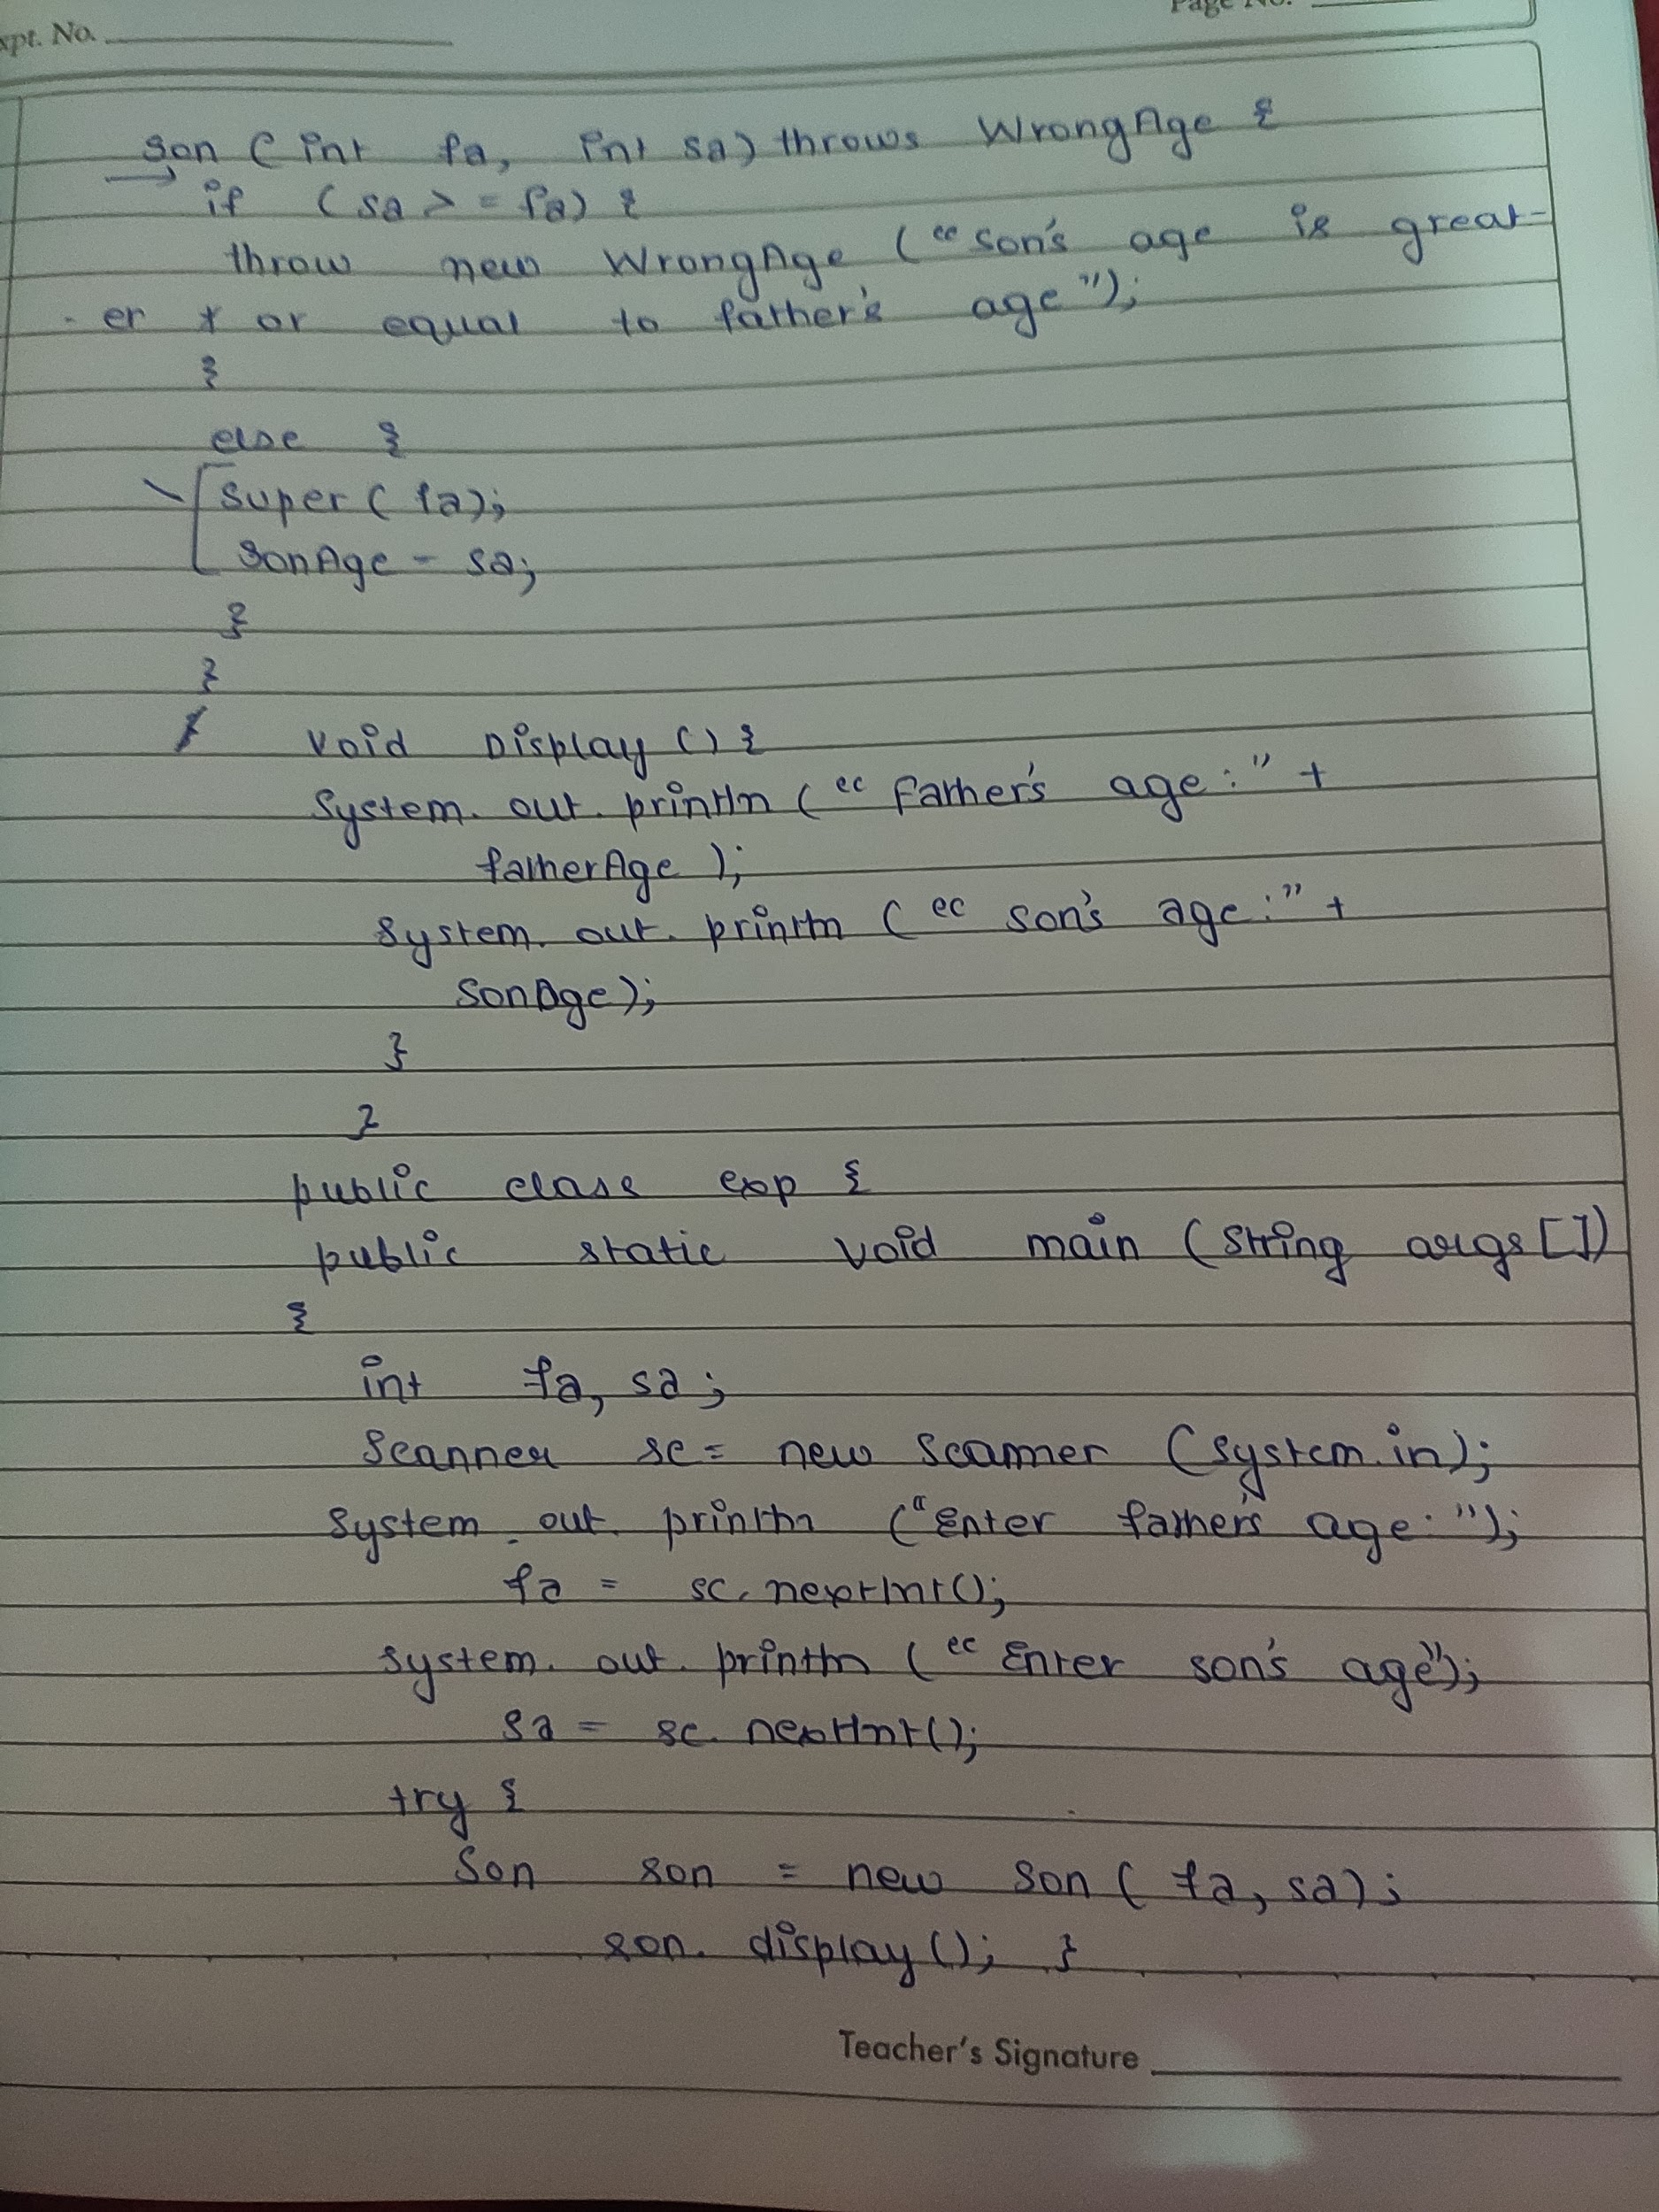

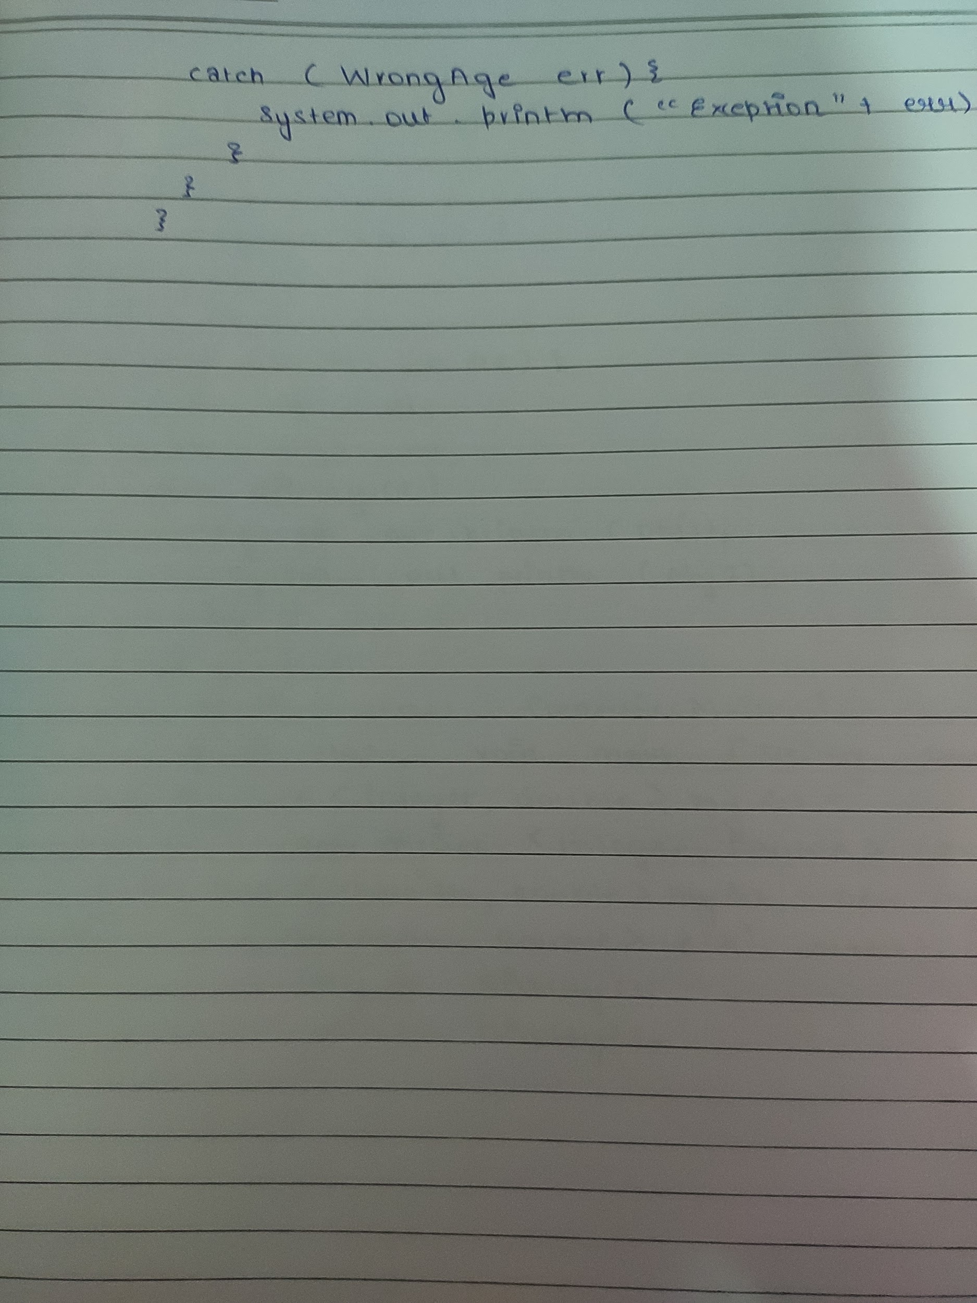

OUTPUT:

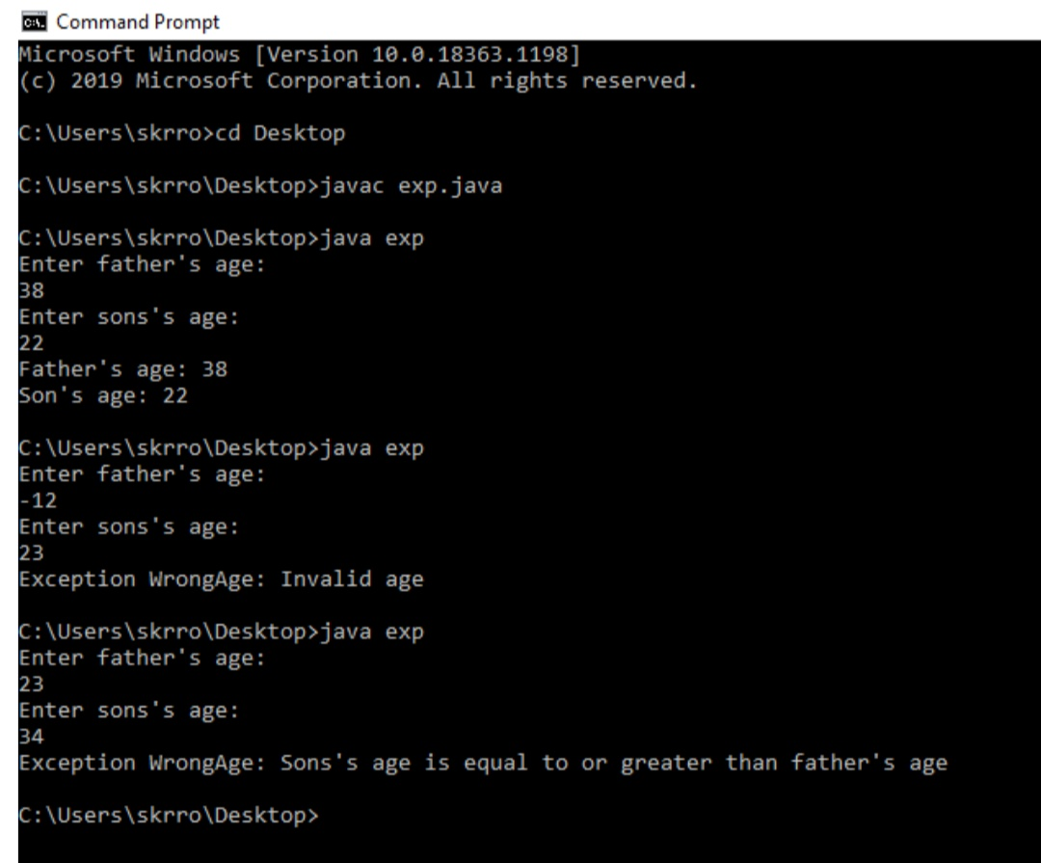

LAB 9:

Write a program which creates two threads, one thread displays "BMS College Of Engineering" every 10 seconds. The other displays "CSE" every 5 seconds.

TYPED PROGRAM:

class BMS extends Thread {

public void run(){

try{

int i=0;

while (i<5){

sleep(10000);

System.out.println("BMS College of Engineering ");

i++;

}

} catch (Exception e){

}

}

}

class CSE extends Thread {

public void run() {

try {

int i=0;

while (i<5) {

sleep(2000);

System.out.println("CSE");

i++;

}

}catch (Exception e) {

}

}

}

class ThreadDemo {

public static void main(String args[]) {

BMS t1 = new BMS();

CSE t2 = new CSE();

t1.start();

t2.start();

}

}

WRITE-UP

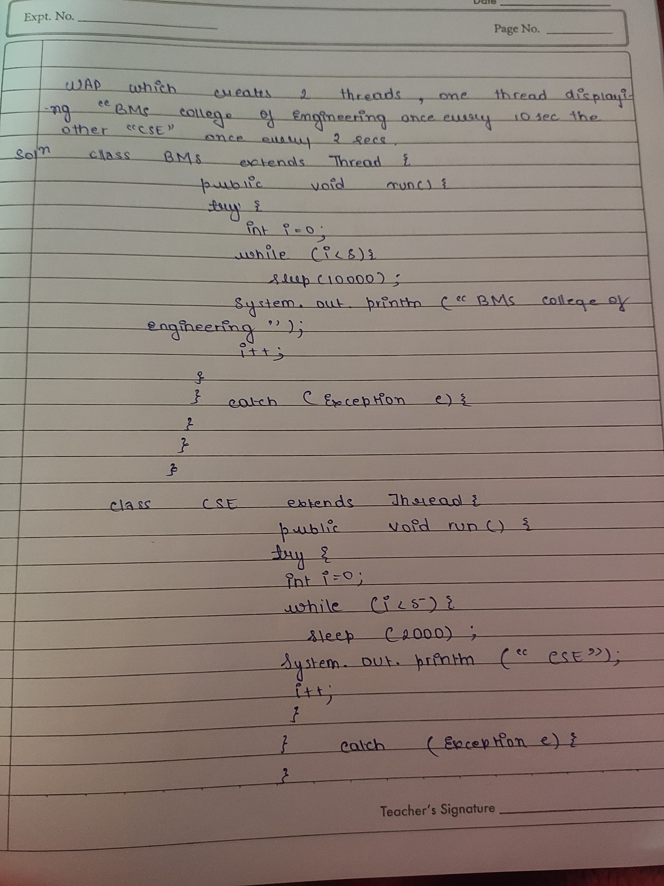

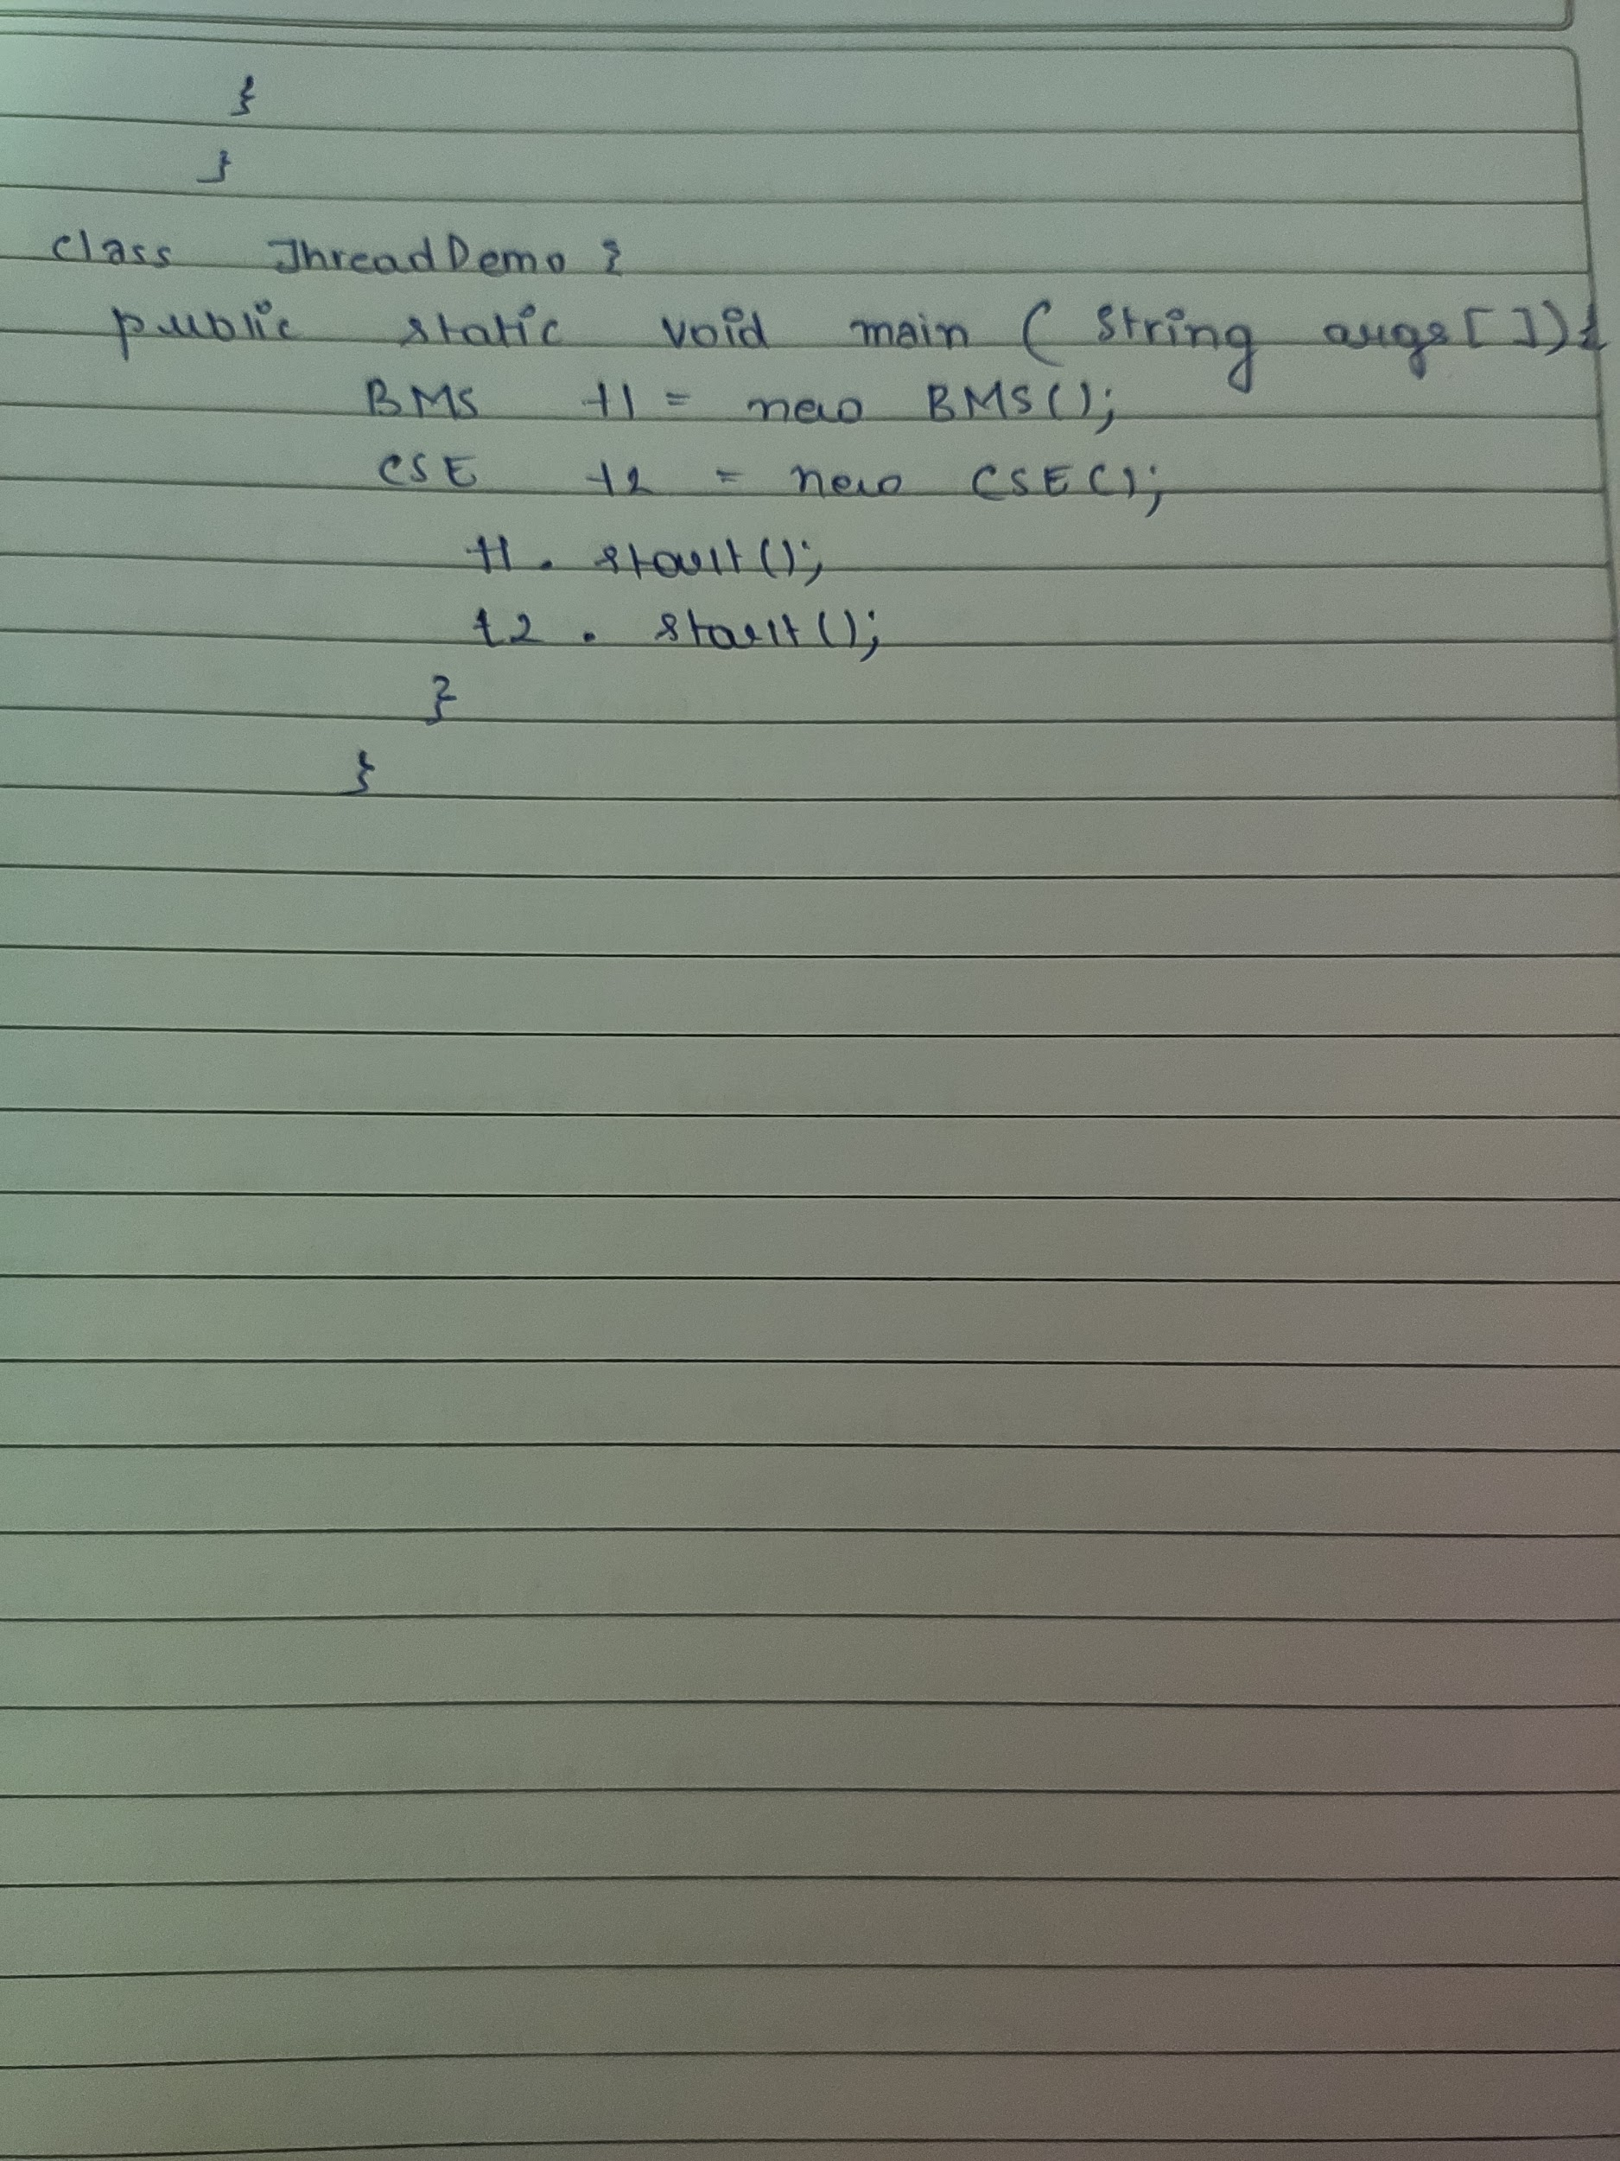

OUTPUT:

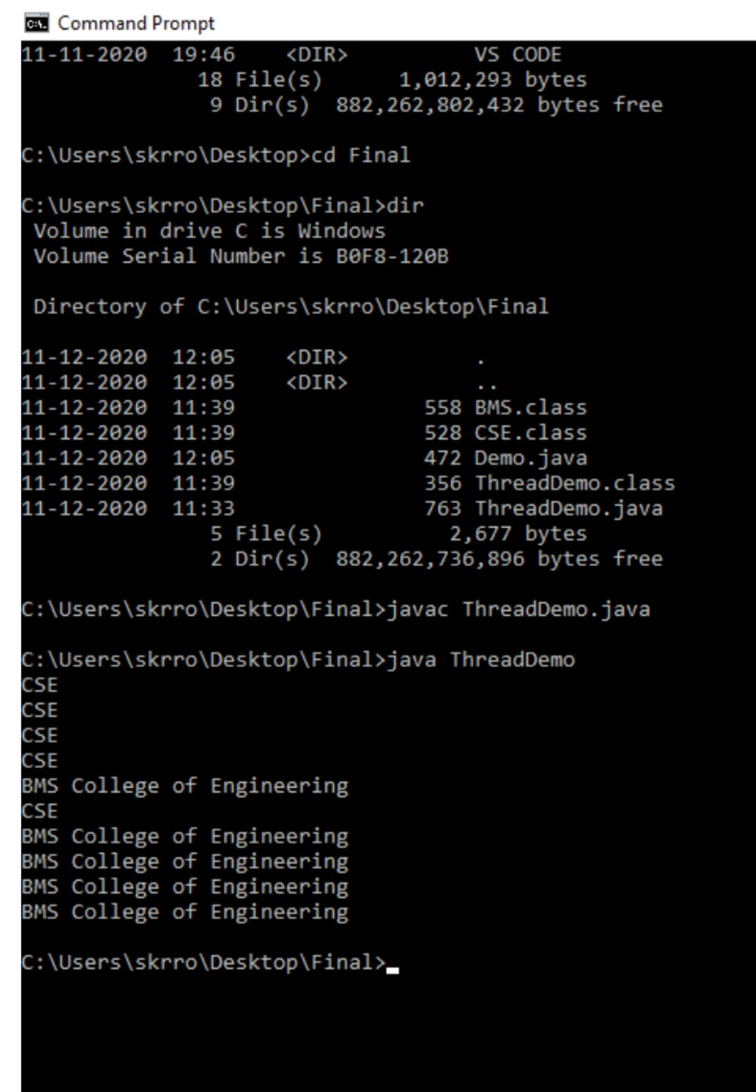

LAB 10:

TYPED PROGRAM:

import java.awt.\*;

import java.awt.event.\*;

public class Lab10 extends Frame implements ActionListener{

TextField t1,t2;

String msg="";

Button btn;

Lab10(){

Label l1 = new Label("First Number: ",Label.RIGHT);

t1 = new TextField(10);

Label l2 = new Label("Second Number: ",Label.RIGHT);

t2 = new TextField(10);

btn = new Button("Submit");

//Label l = new Label("Updates:");

l1.setBackground(Color.YELLOW);

l2.setBackground(Color.YELLOW);

//this.setResizable(false);

this.add(l1);

this.add(t1);

this.add(l2);

this.add(t2);

//t1.setEchoChar('\*');

//t2.setEchoChar('#');

this.add(btn,BorderLayout.CENTER);

this.setVisible(true);

this.setSize(600, 300);

this.setLayout(new FlowLayout(FlowLayout.CENTER,20,10));

//t1.addActionListener(this);

btn.addActionListener(this);

addWindowListener(new MyWindow());

setBackground(Color.YELLOW);

//System.out.println(BorderLayout.CENTER);

}

@Override

public Insets getInsets() {

return new Insets(50,10,10,20);

}

@Override

public void actionPerformed(ActionEvent e) {

String st1 = t1.getText();

String st2 = t2.getText();

double n1,n2;

n1 = 0.0;

n2 = 0.0;

if(st1.equals("")||st2.equals("")) {

msg="You cannot leave the text elements blank";

}else{

try {

n1 = Double.parseDouble(st1);

n2 = Double.parseDouble(st2);

try {

double res = n1/n2;

msg = "Result of division: "+res;

}catch(ArithmeticException e1) {

msg = e1.toString();

}

}catch(NumberFormatException e2) {

msg = "Enter only numbers and not other things";

}

}

new MyDialog(this,"Result Dialog",false,msg,n1,n2);

}

public static void main(String[] args) {

new Lab10();

}

}

class MyDialog extends Dialog implements ActionListener{

public MyDialog(Frame owner, String title, boolean modal,String msg, double n1,

double n2) {

super(owner, title, modal);

this.setVisible(true);

this.setSize(300, 400);

this.setLayout(new FlowLayout());

//System.out.println(owner);

Label l1 = new Label(" Updates on the result: ");

//l1.setSize(300, 20);

this.add(l1);

this.add(new Label("First Number: "+n1));

this.add(new Label("Second Number: "+n2));

this.add(new Label(msg));

Button b = new Button("Close");

this.add(b);

b.addActionListener(this);

this.addWindowListener(new WindowAdapter() {

public void windowClosing(WindowEvent e) {

dispose();

}

});

}

@Override

public void actionPerformed(ActionEvent e) {

dispose();

}

}

class MyWindow extends WindowAdapter{

public void windowClosing(WindowEvent e) {

System.exit(0);

}

}

WRITE-UP

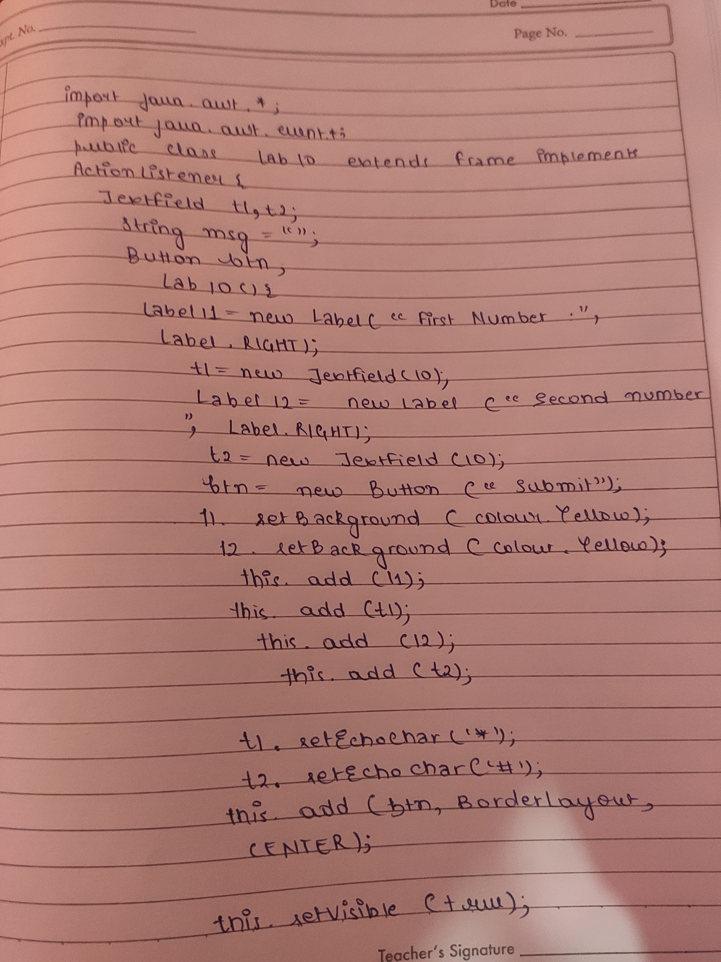

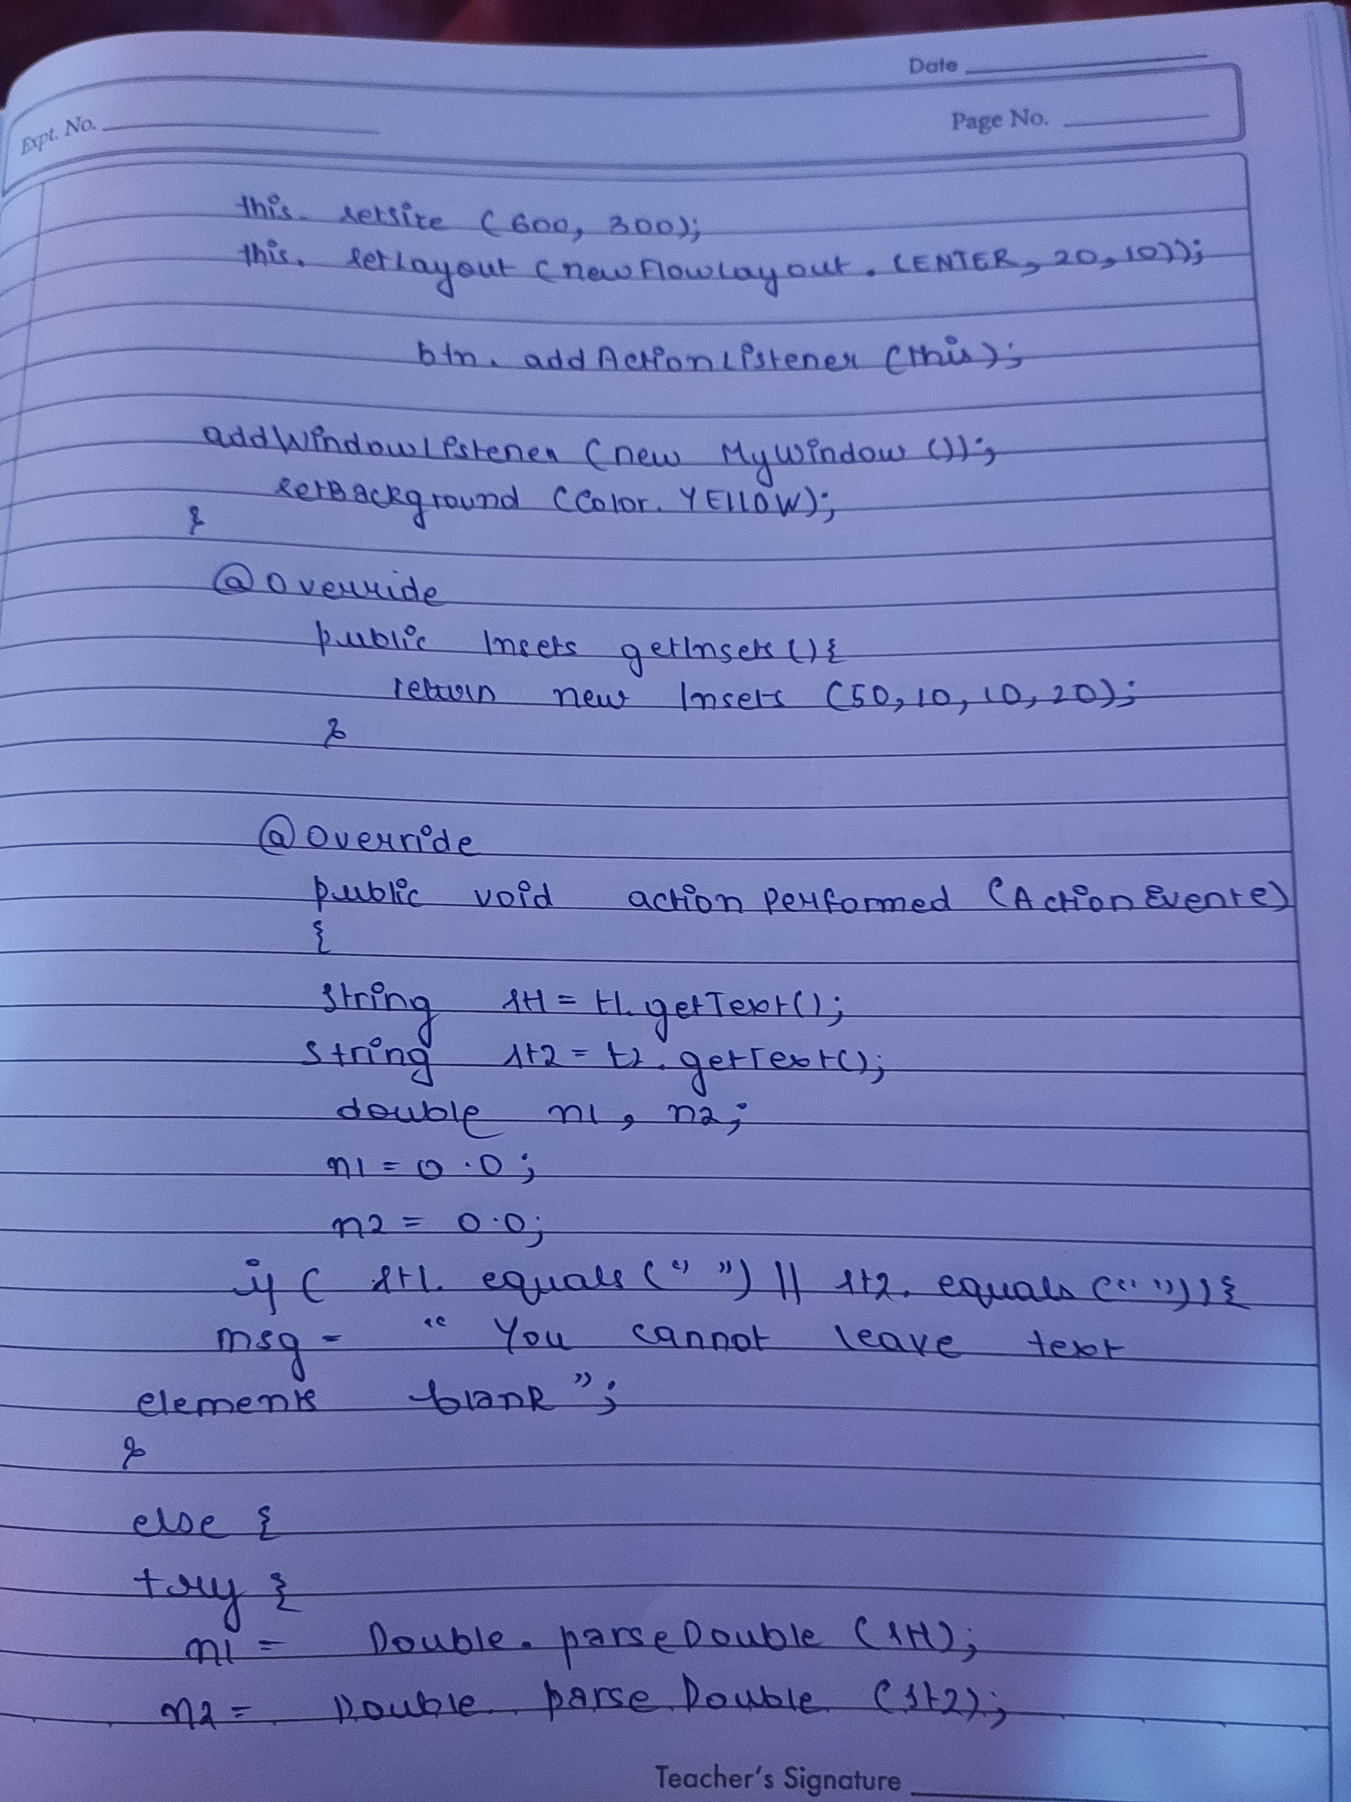

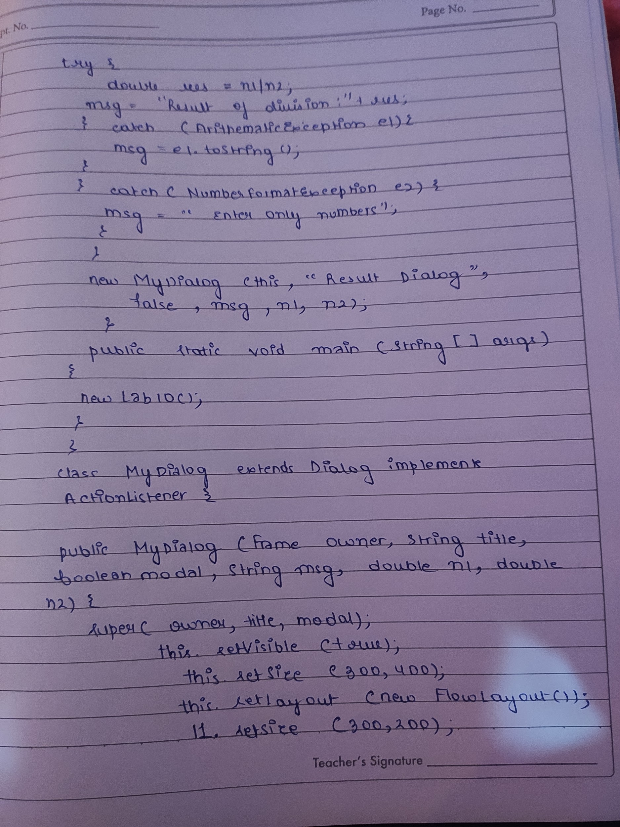

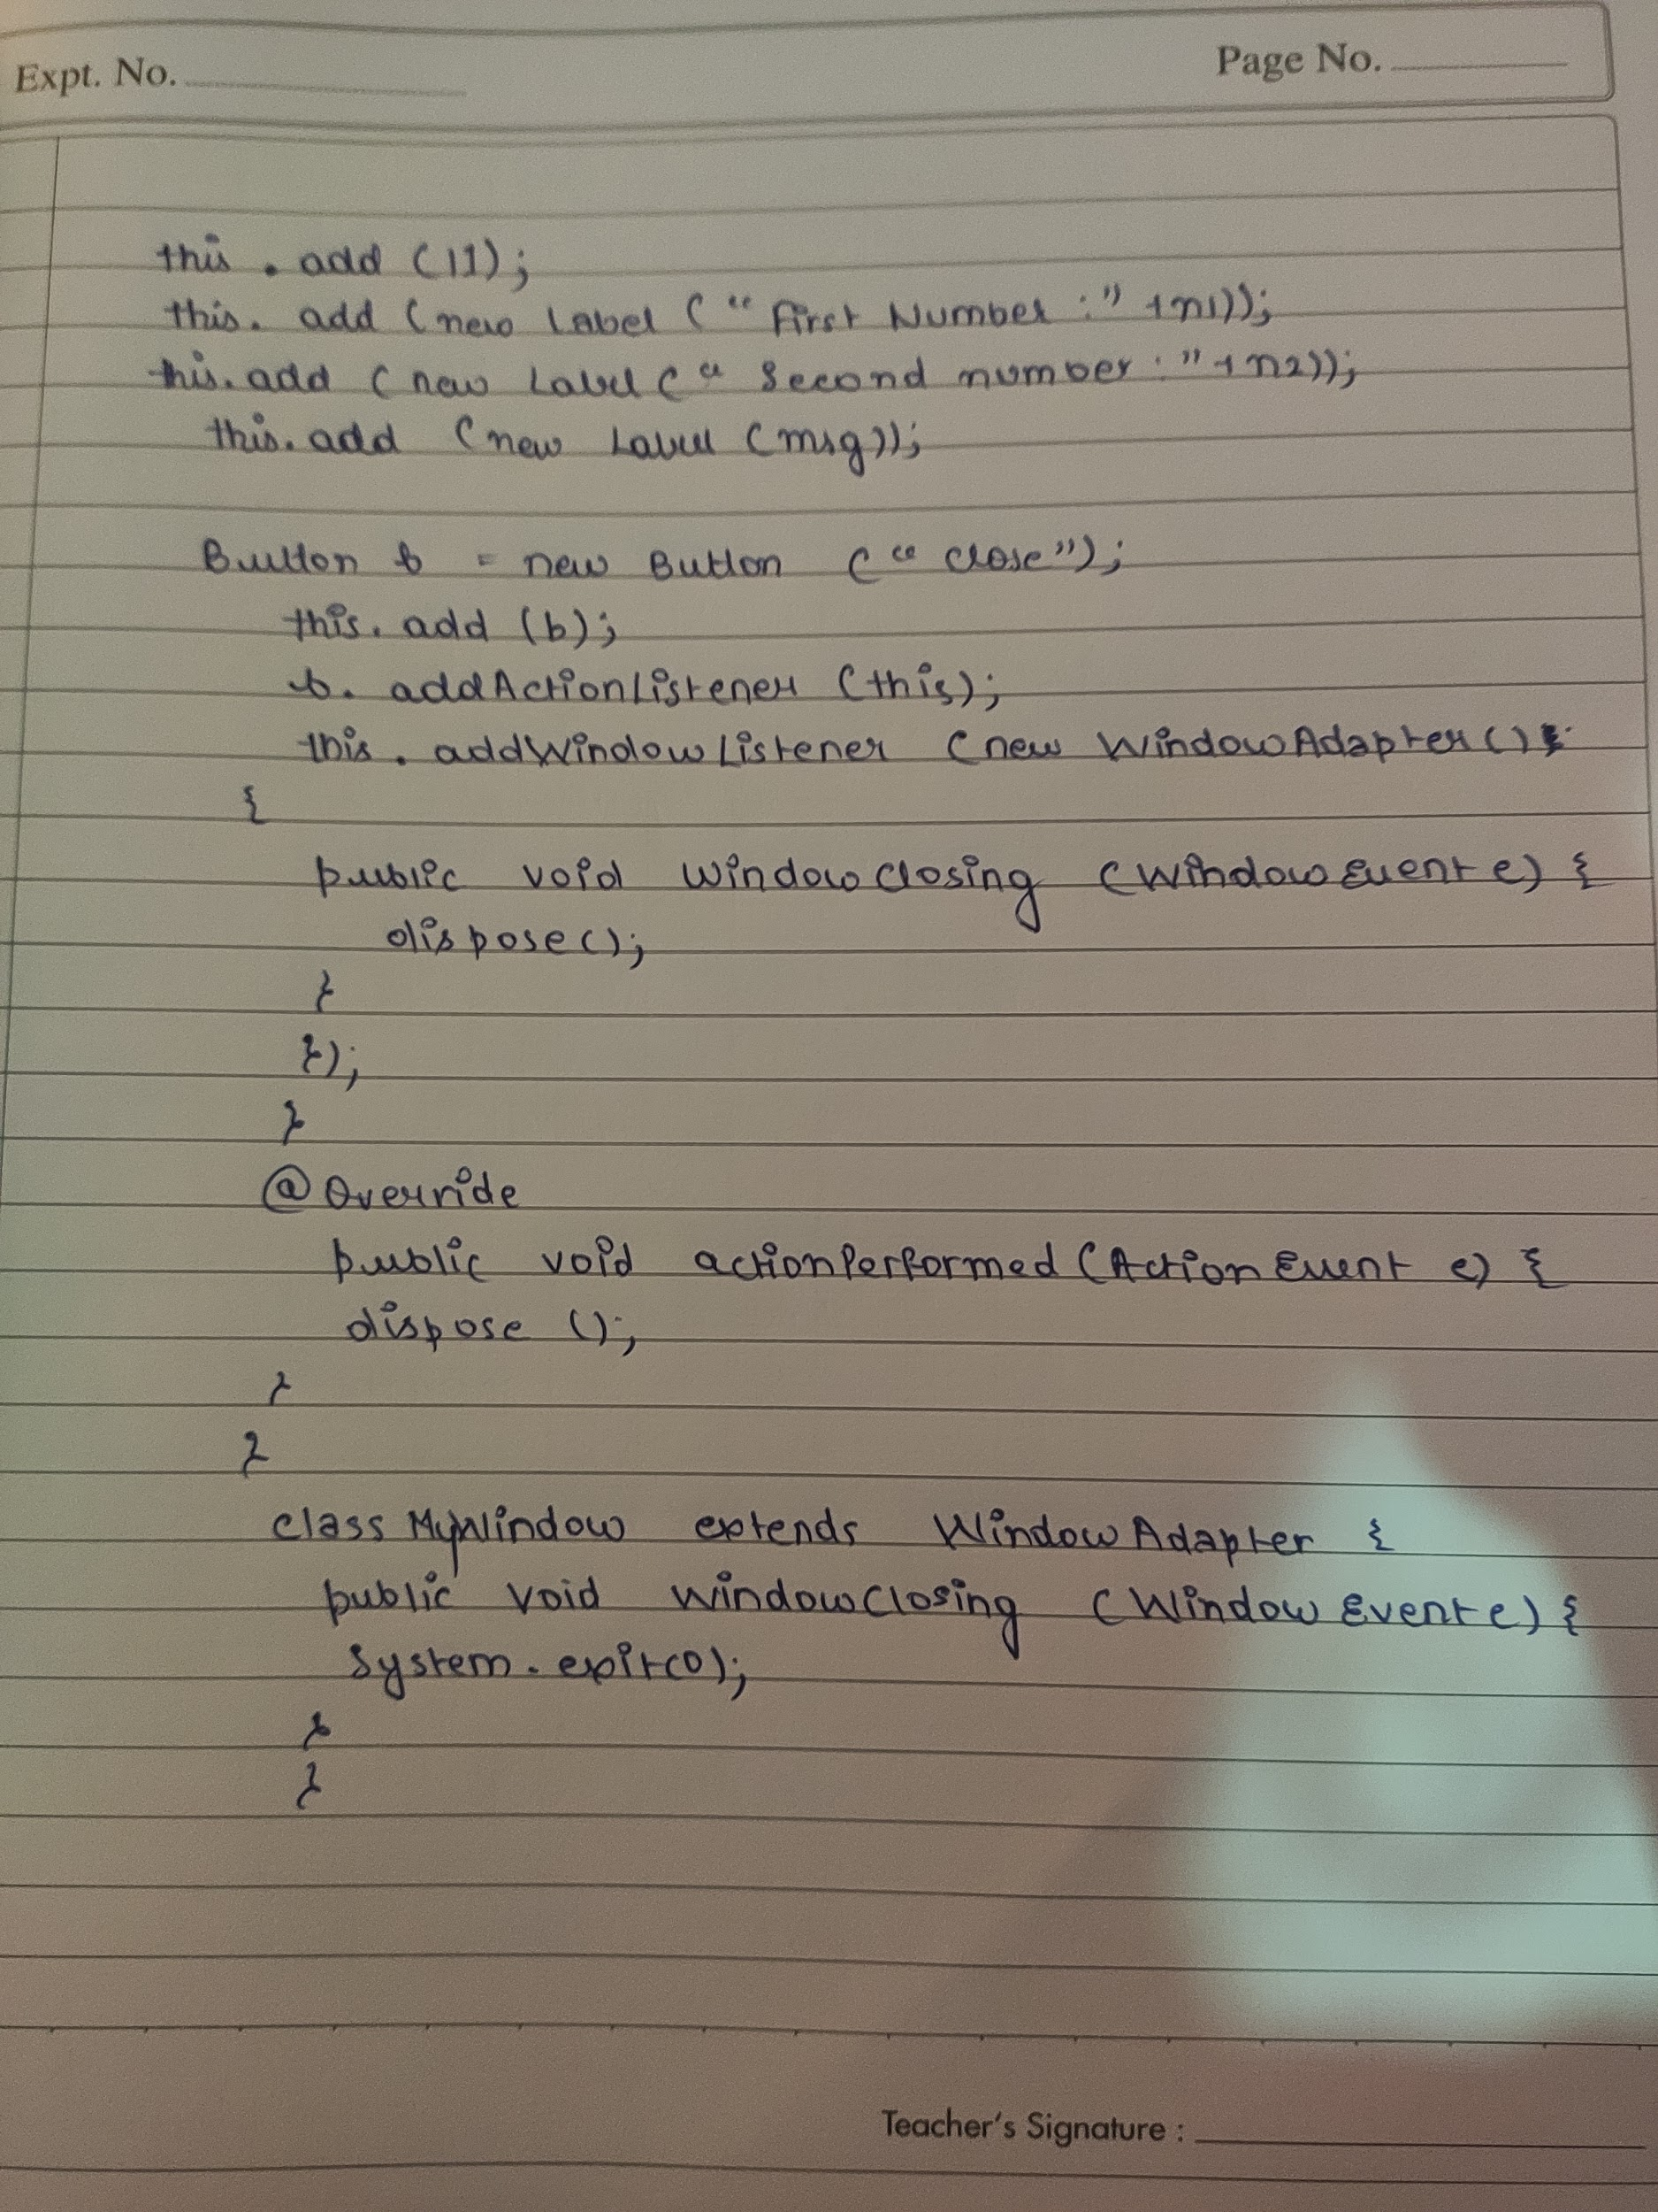

OUTPUT:

